**WHEELCHAIR CONTROLLED BY EYE MOTION**

**Aim:**

A sturdy wheelchair is a walking aid for people with a physical disability or chronic diseases and high blood pressure. To take care of different disabilities, different types of interactions are designed to control the wheelchair; such as toy stick control, head control and sip-puff control.

Many people with disabilities do not have the ability to control a powerful wheelchair using the above ways of meeting. The proposed model is an alternative. In this paper, we use an optical type eye tracking system to control a powerful wheelchair. The user's eye movements are translated into screen mode using the eye type tracking system. When the user checks the appropriate angle, the computer input program will send a command to software based on student rotation that is, when the user is moving his or her eyes upwards (go forward), left (move left), right (move right) on all other wheelchairs will stand. Once the image is used it goes away the second part, our microprocessor. The microprocessor will extract the USB output from the laptop and convert the file to sign the signals that will be sent to the wheelchair wheels to move. Also, the pressure and discovery of the object the sensors will be connected to our microprocessor to provide the required response for file operation efficiency wheelchair system. The final part of the project is the wheelchair itself. The rear wheels will provide forward. The front two wheels will be used to steer left and right. All four wheels will be connected to our microprocessor which will send signals to control the wheels as well as general movement.

Keywords: Electronic wheelchair, Optical wheelchair, Electronic wheelchair using image analysis method or procedure.

**Hardware & Software Requirements:**

A. Camera

B. OpenCV

C. Serial Interface

D. Microcontroller

E. Wheel Chair Prototype

SYSTEM HARDWARE

The hardware components used in the system design are explained in detail in the following sections.

* AT 89S52 Development Board
* AT89S52 Microcontroller
* RS 232 Standard
* Motor Driver Circuit

SOFTWARE REQUIREMENTS

The soft wares used for creating and programming of the various modules to obtain the desired results are as follows:

1. OpenCV 3.0.0
2. Eclipse 3.8

**\**

**Project Flow**

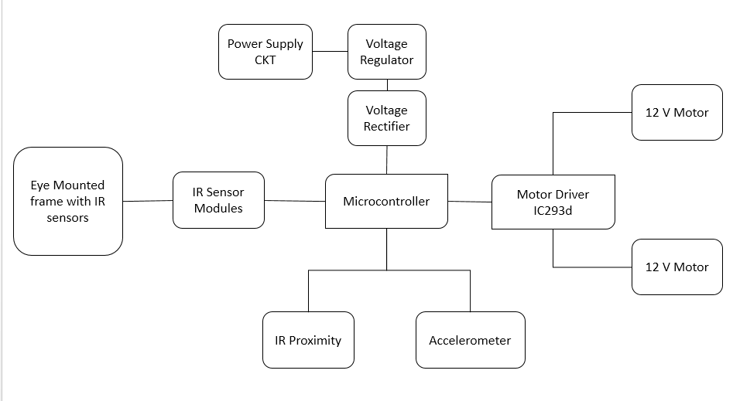

Accelerometer

Camera

The system consists of three main parts:

1. Head mounted camera and laptop system that tracks the camera wearer’s eye.
2. The microprocessor takes an output from the laptop and converts the digital output to electric signals that is sent to the wheelchair wheels for movement.
3. A signal triggered Wheel Chair and the web camera is used to detect the eyes movement which is further processed to drive the motors. Serial communication is used to communicate between the web camera and the microcontroller. The microcontroller placed on the wheel chair which is connected to the motors, driving the wheel chair in the direction the person desires to move in.

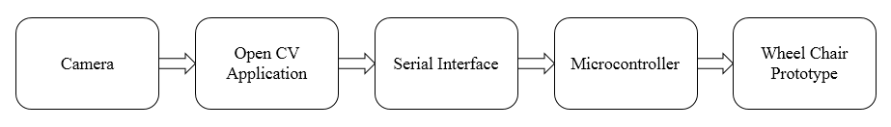

**Proposed Model**

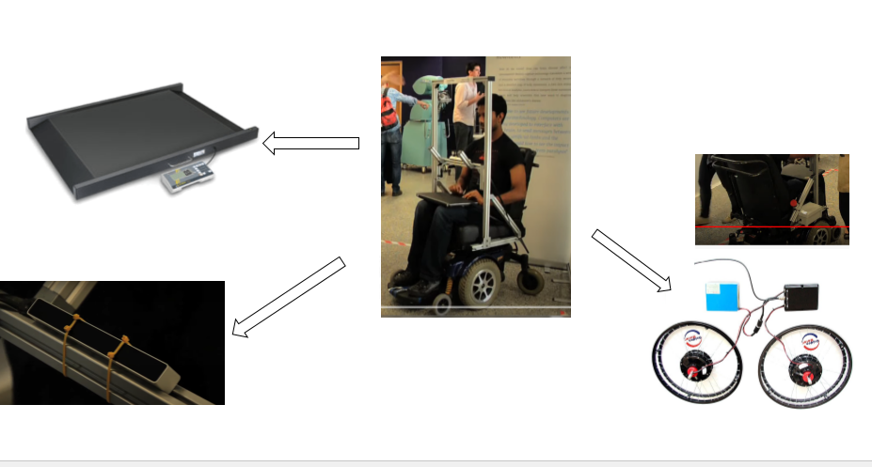

**Stakeholders:**

Generally It is first applicable to those who are differentially abled or Disables, In short, and these people need the most as they are the main target in this project.

Secondly come the people who take care of these people like the employees like caretakers, nurse, etc. and even friends and relatives of the disabled patient.

Finally it can even be used for the commercial purpose like people who make in films or documentary, and also the researchers who try to make it more convenient and affordable for the needy.